* Can we educate the whole campus or should we focus on residence?(survey)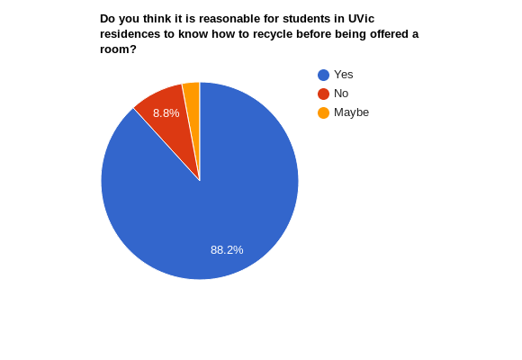
* After talking to Jason Wolting we should focus on Residence
* Most survey respondents felt residence students should know how to properly recycle before being offered a room (85.3%) only 8.8% (3 respondents) felt it was not necessary
* According to Jason wolting contamination is biggest in residences, so there should be a focus on learning how to properly clean your recycling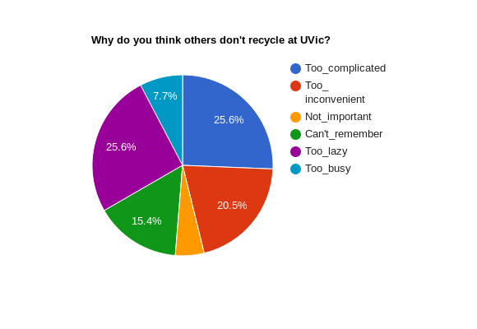
* 58.1% of respondents said they were too lazy to recycle and 41.9% said it was too inconvenient and 51.6% said it was too complicated, if we are going to make improvements to our recycling program in residence it needs to be easy and convenient to recycle, as the current system is neither.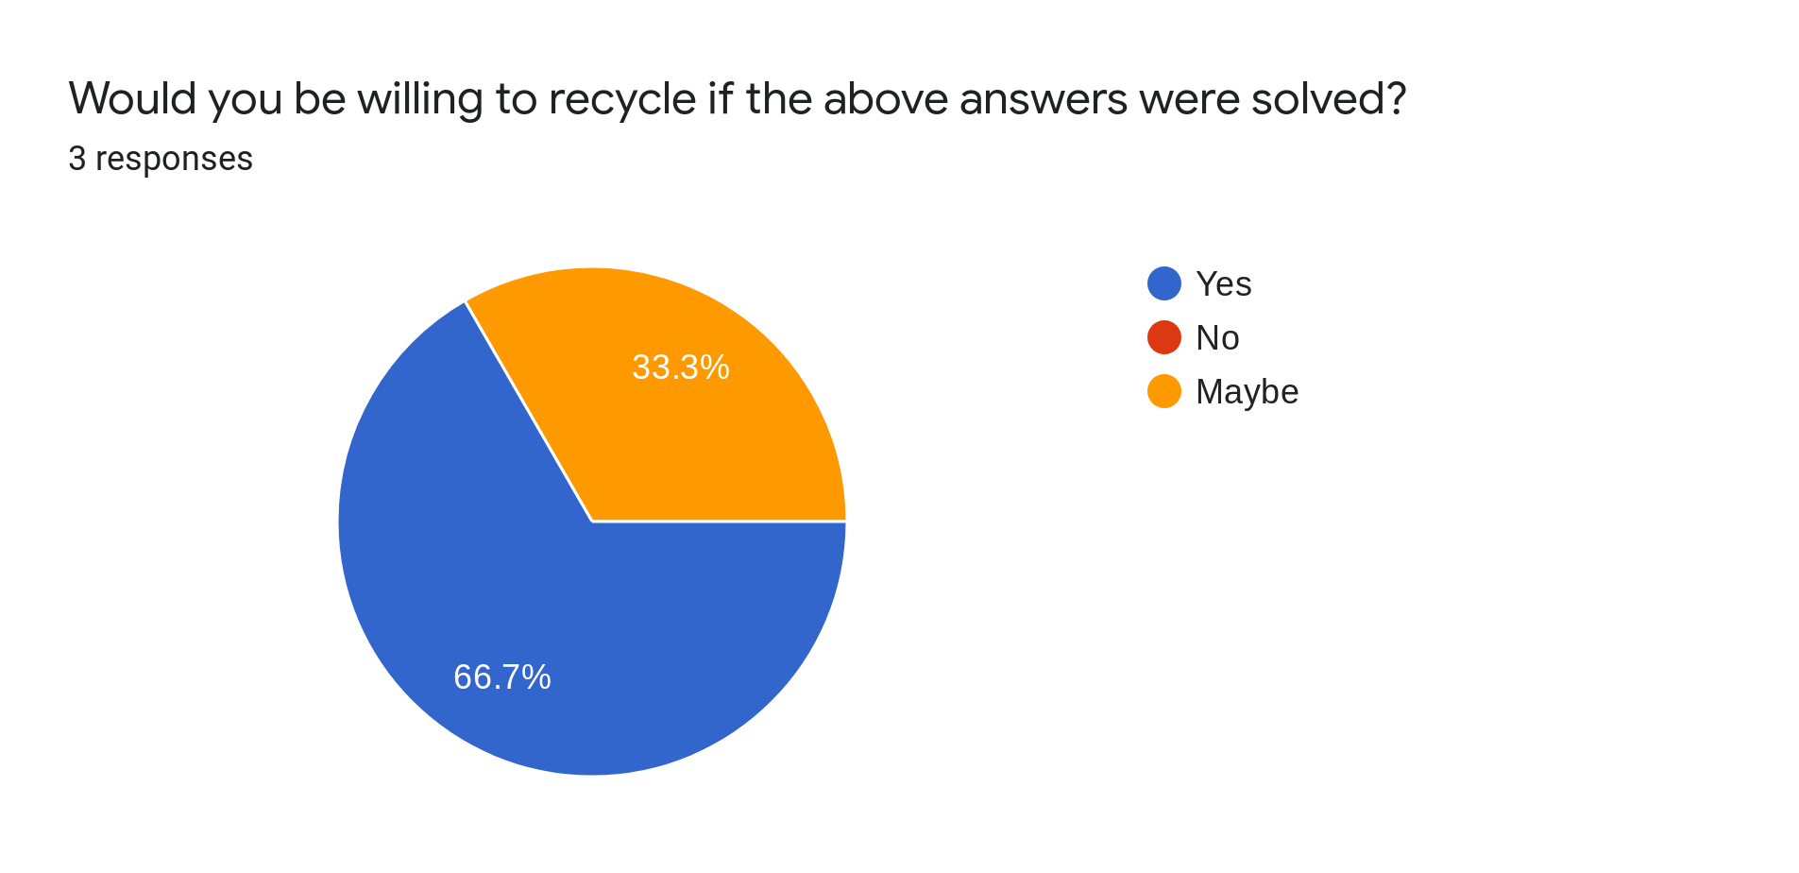
* What aspects of recycling do people have issues with?(survey)
* People struggle with the current program not being convenient or simple enough
* 66% of respondents who said they do NOT recycle said they would consider it if it was easier and more convenient
* It was noted that residence garbage dump areas do not have a lot of proper recycling options and a student thought someone helping sort through recycling would be helpful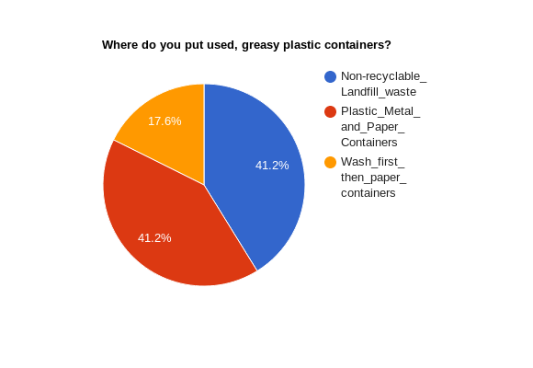
* 41.2% thought greasy plastic packaging was to go into the garbage, only 11.6% responded that the container should be washed then placed in the recycling. 23.8 % said they do not wash out any of their recycling Washing stations could create an easier more convenient system to ensure students can easily wash their containers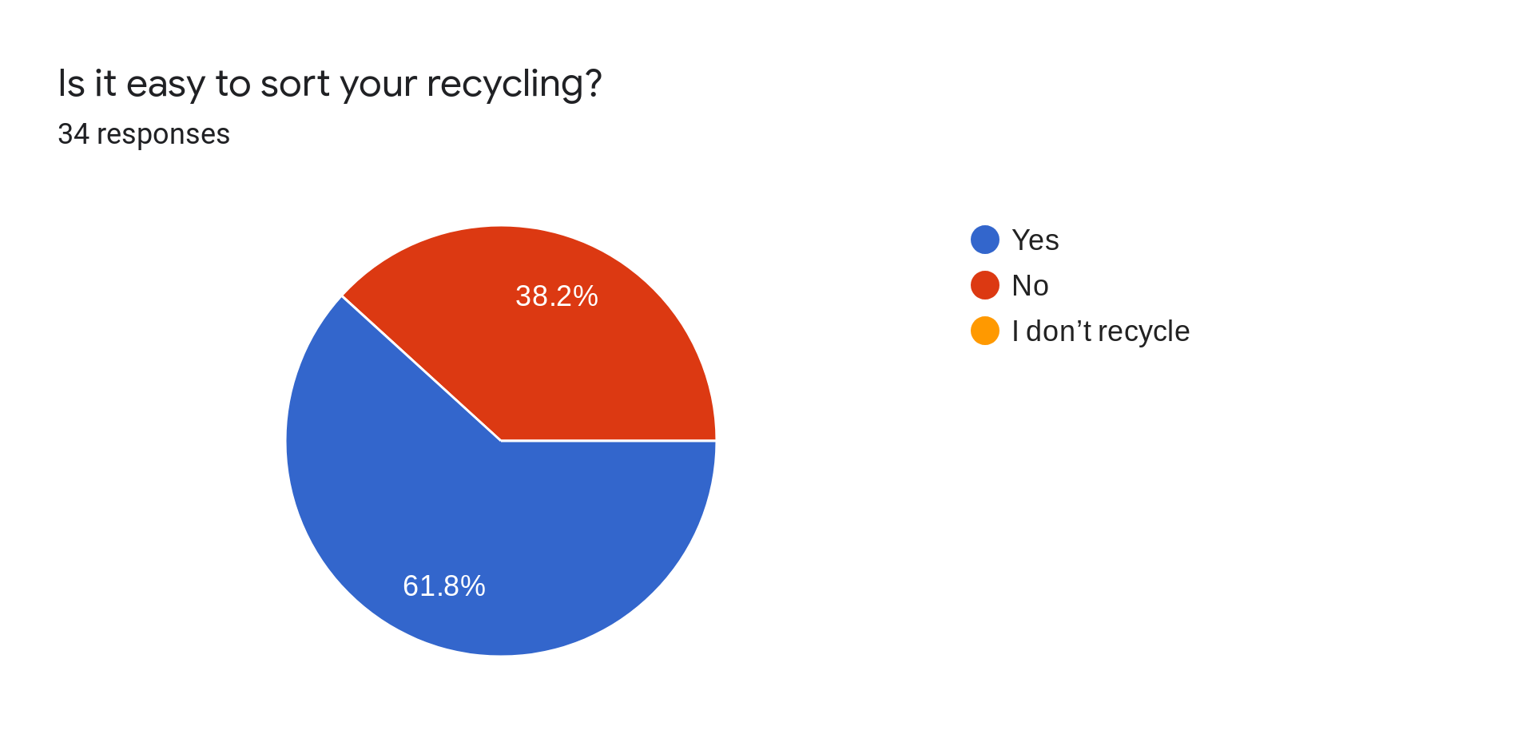
* 38.2% of respondents said it was not easy to sort your recycling, this could be solved through an educational program teaching students which common daily items can be
* recycled and which items, along with appropriate and informative signage above 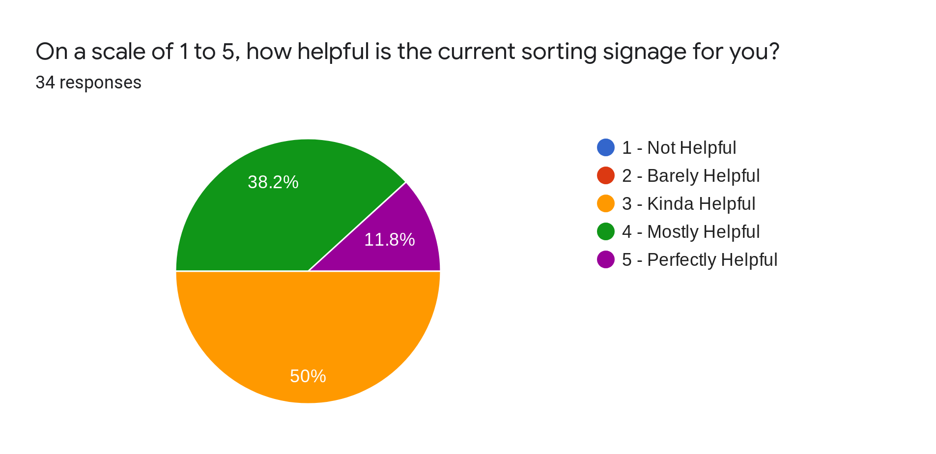
* recycling stations especially considering 50% said the current signage was only kind of helpful.
* Respondents when asked how recycling could be easier offered suggestions like cleaning stations, clearer signage, more instructions and education, having sorters, areas to pour excess liquids from drinks, and more accessible bins
* Are there any issues with the current on-campus garbage sorting system?(survey)
* Respondents said uvic has given little instruction on how to recycle aside from the signage above the bins